Proteins
Elements -
Monomer of proteins –

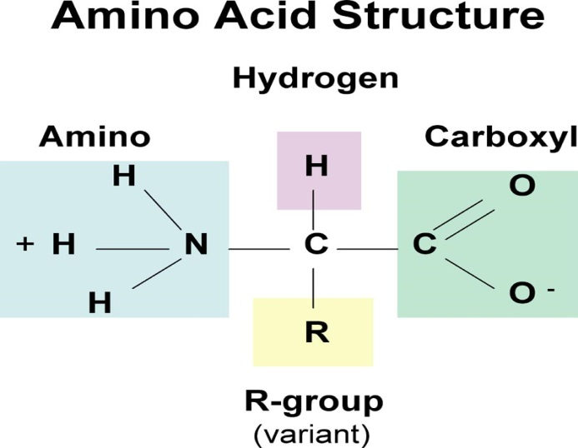
Proteins are assembled by ribosomes using instructions and different amino acids.

What makes amino acids different from one another?
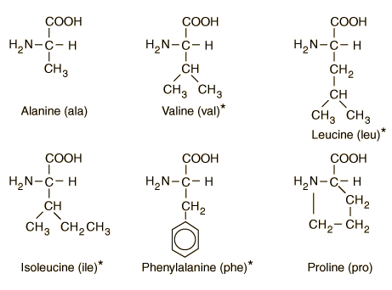
POLYPEPTIDE -

Bonds between amino acids are called .
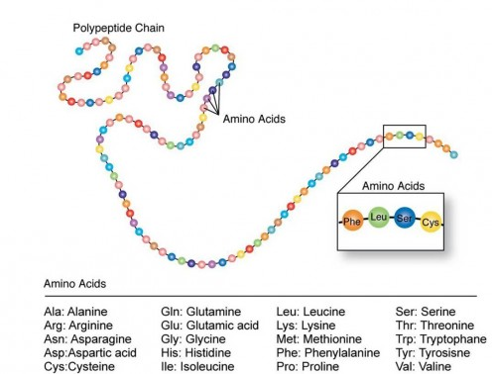

Protein Folding!
Structure of Proteins determines their function!
